AKF TRAINING CAMP 2016

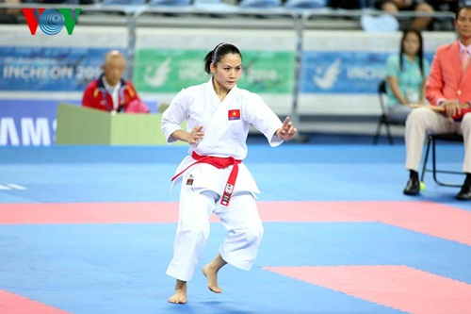

20th - 22nd MAY 2016
THANH HOA, VIETNAM

WELCOME
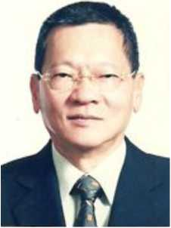
Dear,
I would like to welcome all participants to the AKF Training Camp, Thanh Hoa, Vietnam 2016.
In this edition of Training Camp, AKF invited two renown Karate Sensei to conduct the training; namely Sensei Tsuguo Sakumoto for kata training, and Sensei Masao Kagawa for Kumite training. I believed that all participants will benefit tremendously from the camp.
The objective of the camp is not only aiming to improve the standard of Karate skill of the participants but also to foster a better understanding of each other and friendship regardless of language and culture.
In addition, this edition of Training Camp is also part of AKF effort to promote and support our sport to be included in the Olympic Games, Tokyo 2020.
Lastly, I would like to thank Mr. Pham Dang QUYEN, Vice Chairman of the People’s Committee of Thanh Hoa Province, Chairman of the Organizing Committee of the Vietnam Open Karate-do Championship, 2016 in Thanh Hoa for their great effort to make this edition of Training Camp possible. At the mean time, I shall look forward to meet up with all of you soon in Vietnam.

Mr. Chang, Kuang - Huei,
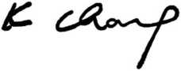
President Asian Karatedo Federation.

WELCOME
Dear,
Vietnam Karate Federation (VKF) in cooperation with Asian Karatedo Federation (AKF) are pleased to invite you to participate in AKF TRAINING CAMP 2016 scheduled on May 20th - 22nd, 2016 in Thanh Hoa, Vietnam. The event held annually in order to give athletes the opportunities to exchange skills and strengthen the friendships with the attendants from many countries.
Through the various activities ranging from seminars to practices, we believe that the three-day event will be the meaningful one to all of us.
We earnest look forward to welcoming you in Vietnam.

Yours Sincerely,
Mr. Vu Son Ha,

Secretary General

Vietnam Karate Federation.

DATE & VENUE
DATE : 20th - 22nd May 2016.
VENUE :
- HQ Hotel: MUONG THANH HOTEL (4 stars)
Add: Dong Ve Ward, Thanh Hoa City, Thanh Hoa Province, Vietnam.

CONTACT INFORMATION

VIETNAM KARATE FEDERATION (VKF)
Ad: 36 Tran Phu Str., Badinh Distr., Hanoi, Vietnam
E-mail: sonhakarate@yaoo.com; lhhanh2502@yahoo.com.

ENTRY
- VKF only accept entries by NF, namely Dojos or Clubs, which are interested, to participate must send entries via their National Karate Federation.
- One NF have unlimited participants entries.
- Training Camp can accept 500 participants at most, so first come first served policy will be applied.
- Age group: only Cadet, Juniors and Seniors (with AKF/WKF Karate Knowledge).
- NFs and participants must stay in HQ official hotel and make reservation via VKF only.
- NFs and participants take full responsibility for their participants, behavior and public image within or outside venue. In case of negative impact to AKF, VKF, karate-do sport or general public caused by participants, the NFs and participants concerned will be imposed disciplinary action.

REGISTRATION
TIME : 09:00 - 20:00, 20th May 2016.
VENUE : HQ Hotel.

SENSEI

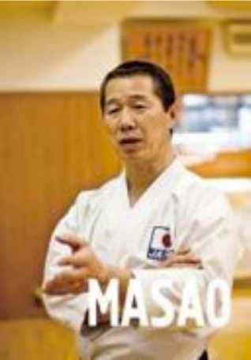

SENSEI KAGAWA MASAO (KUMITE)
DIRECTOR OF NATIONAL JAPAN KARATE TEAM
WKF CHAIRMAN TECHNICAL DIRECTOR
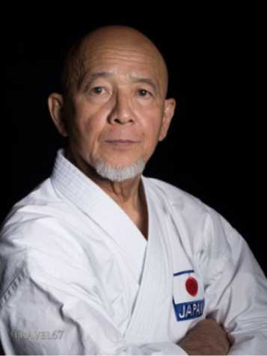

SENSEI TSUGUO SAKUMOTO (KATA)
EX WKF CHAIRMAN TECHNICAL DIRECTOR

PROGRAM
MAY 20th, 2016
TIME | EVENT | VENUE
ALL DAY | Arrival National Delegations. | HQ HOTEL
15:00 - 20:00 | Official Registration Delegations.
20:00 - 21:00 | Welcome Ceremony and presentation program.
MAY 21st, 2016
TIME | EVENT | VENUE
07:00 - 08:30 | Aerobic coaching | HQ HOTEL
08:30 - 09:30 | Breakfast
10:00 - 12:00 | Kumite Kata training per discipline
12:00 - 13:00 | Lunch
13:00 - 15:00 | Rest
15:00 - 18:00 | Kumite Kata training per discipline
19:00 - 20:00 | Dinner
20:00 - 22:00 | Team Building
MAY 22nd, 2016
TIME | EVENT | VENUE
07:00 - 08:30 | Aerobic coaching | HQ HOTEL
08:30 - 09:30 | Breakfast
10:00 - 12:00 | Kumite Kata training per discipline
12:00 - 13:00 | Lunch
13:00 - 14:00 | Rest
14:00 - 17:00 | Kumite Kata training per discipline
18:00 - 19:00 | Dinner
19:00 - 20:00 | Team Building
17:00 - 18:00 | Closing Ceremony.
MAY 23rd, 2016
DEPARTURE |  | HQ HOTEL

HEADQUARTER HOTEL

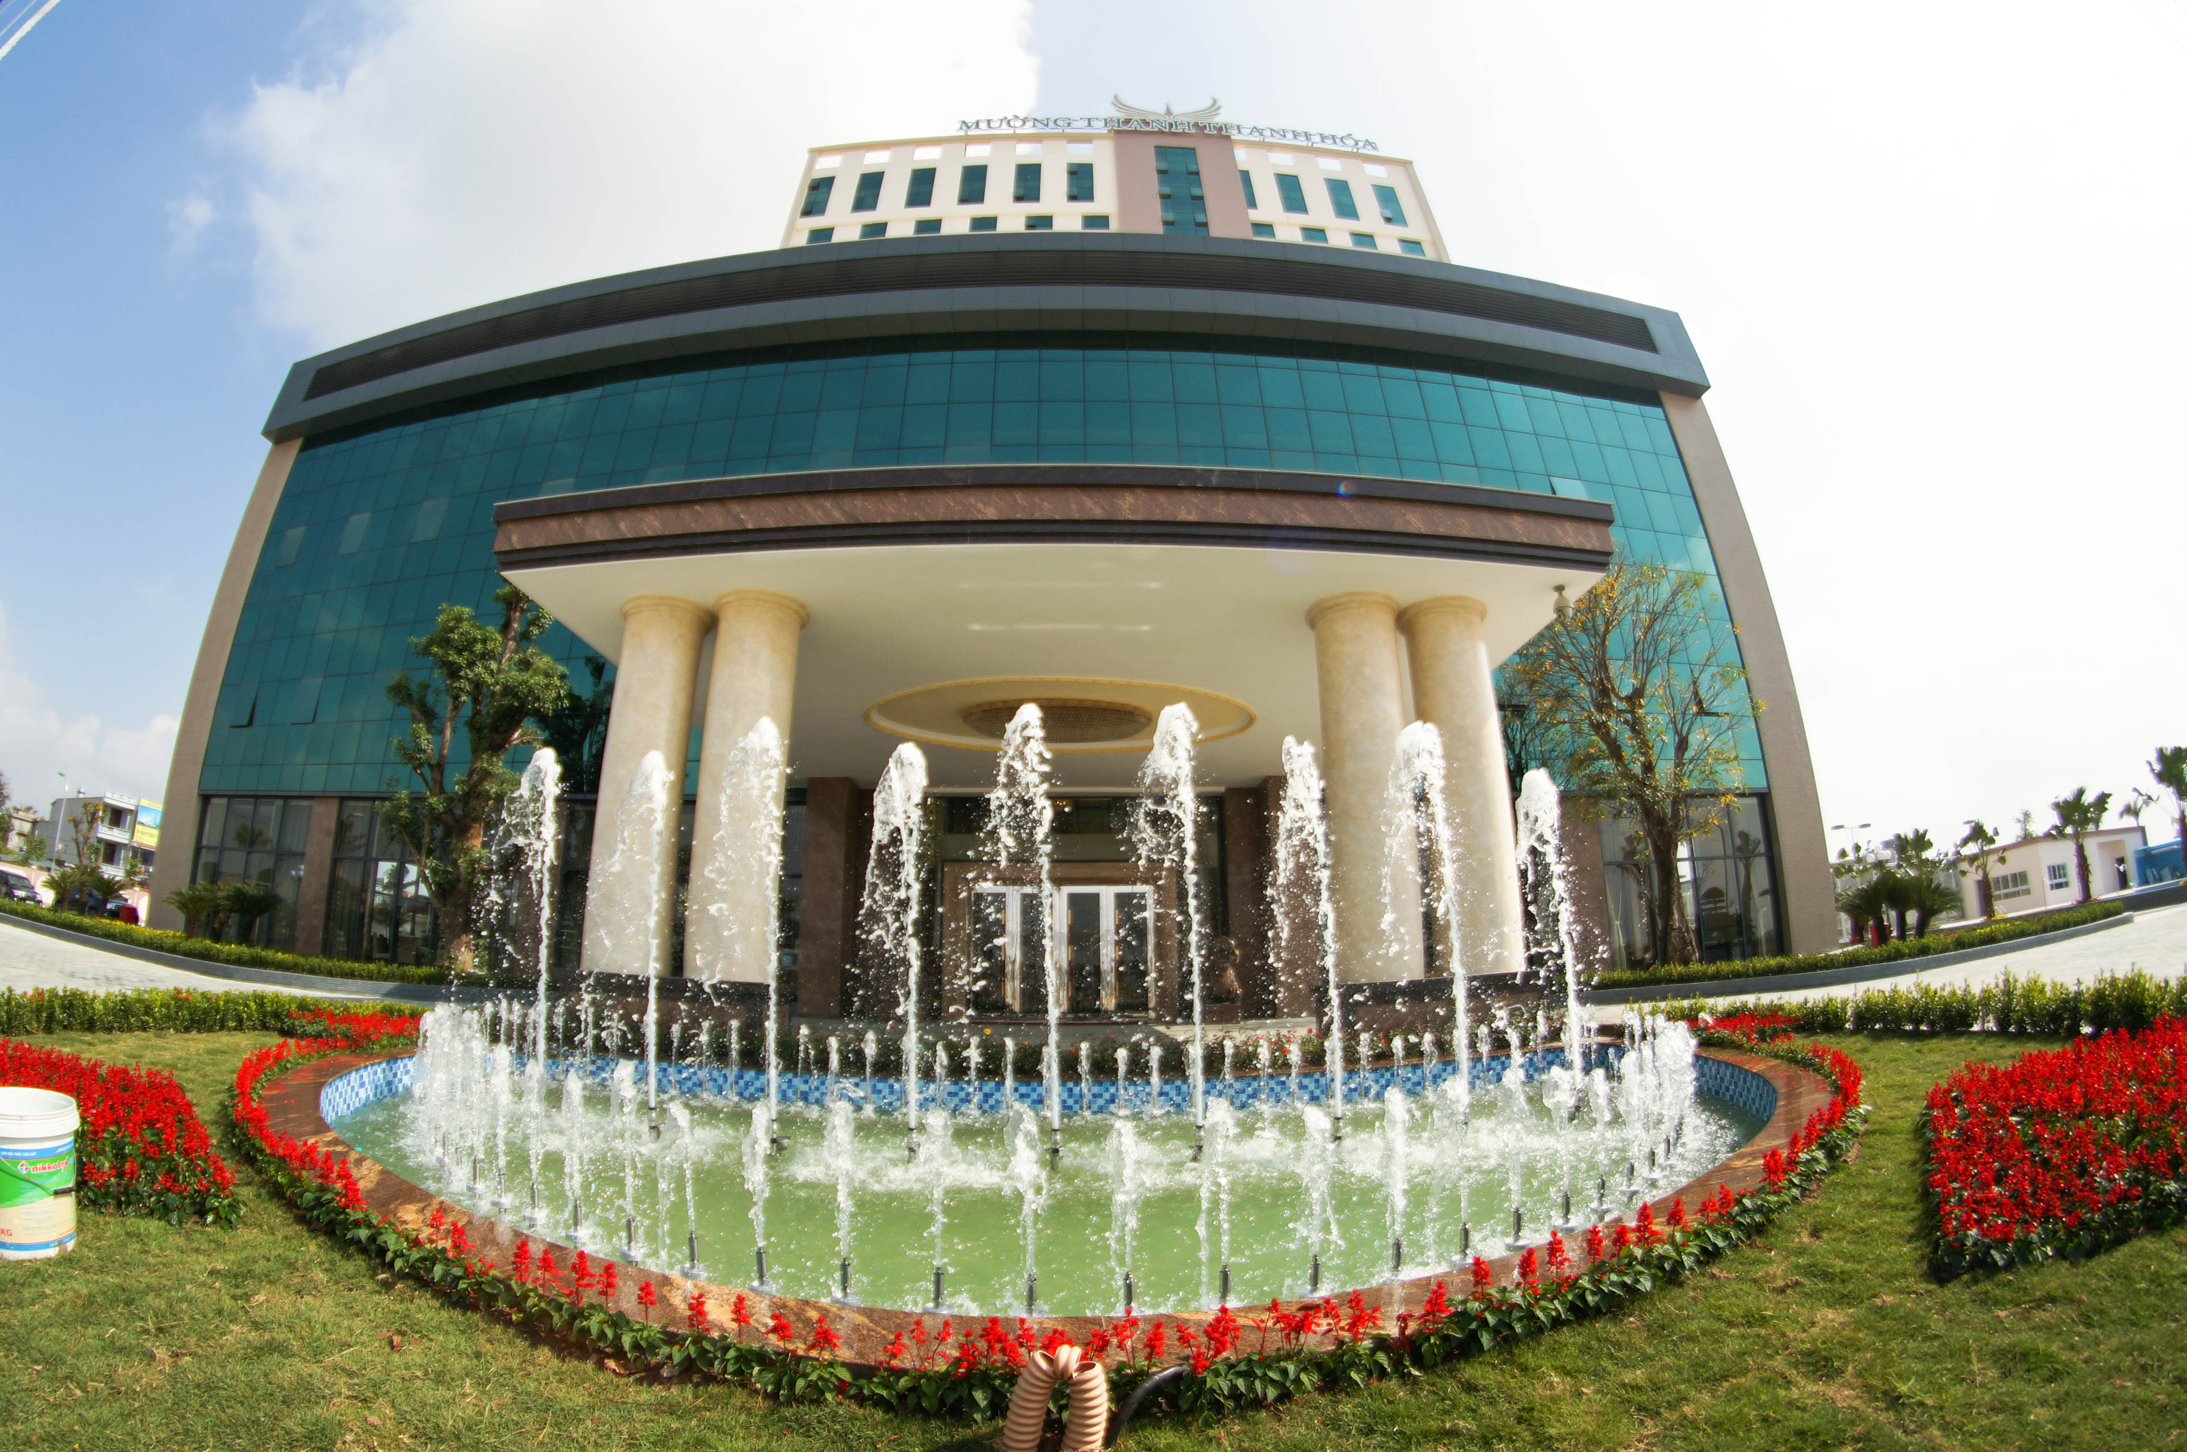
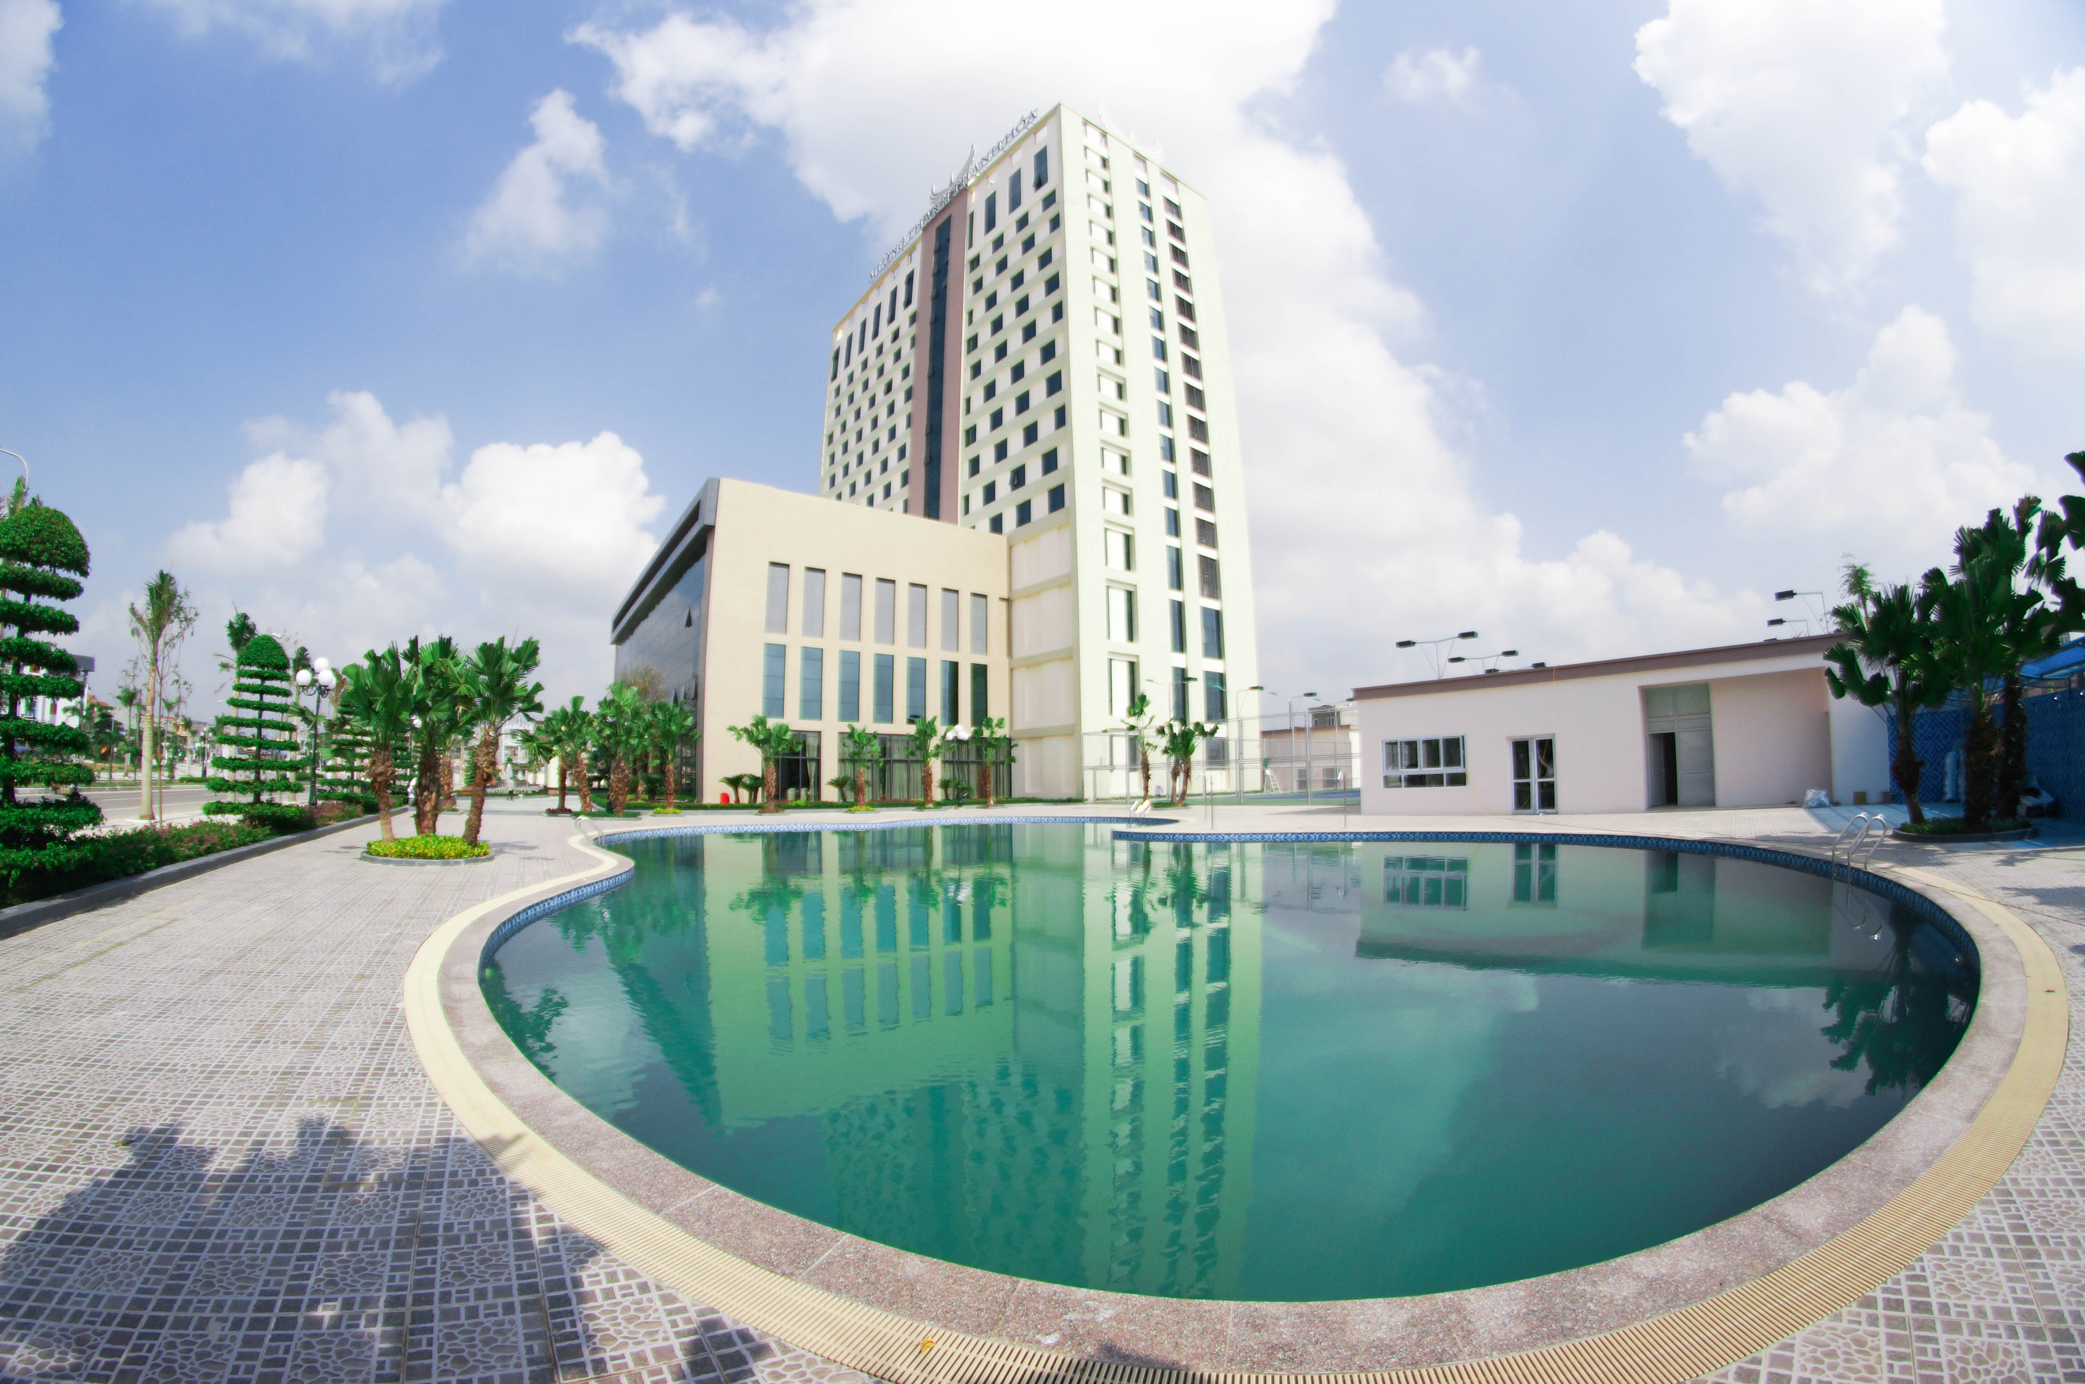
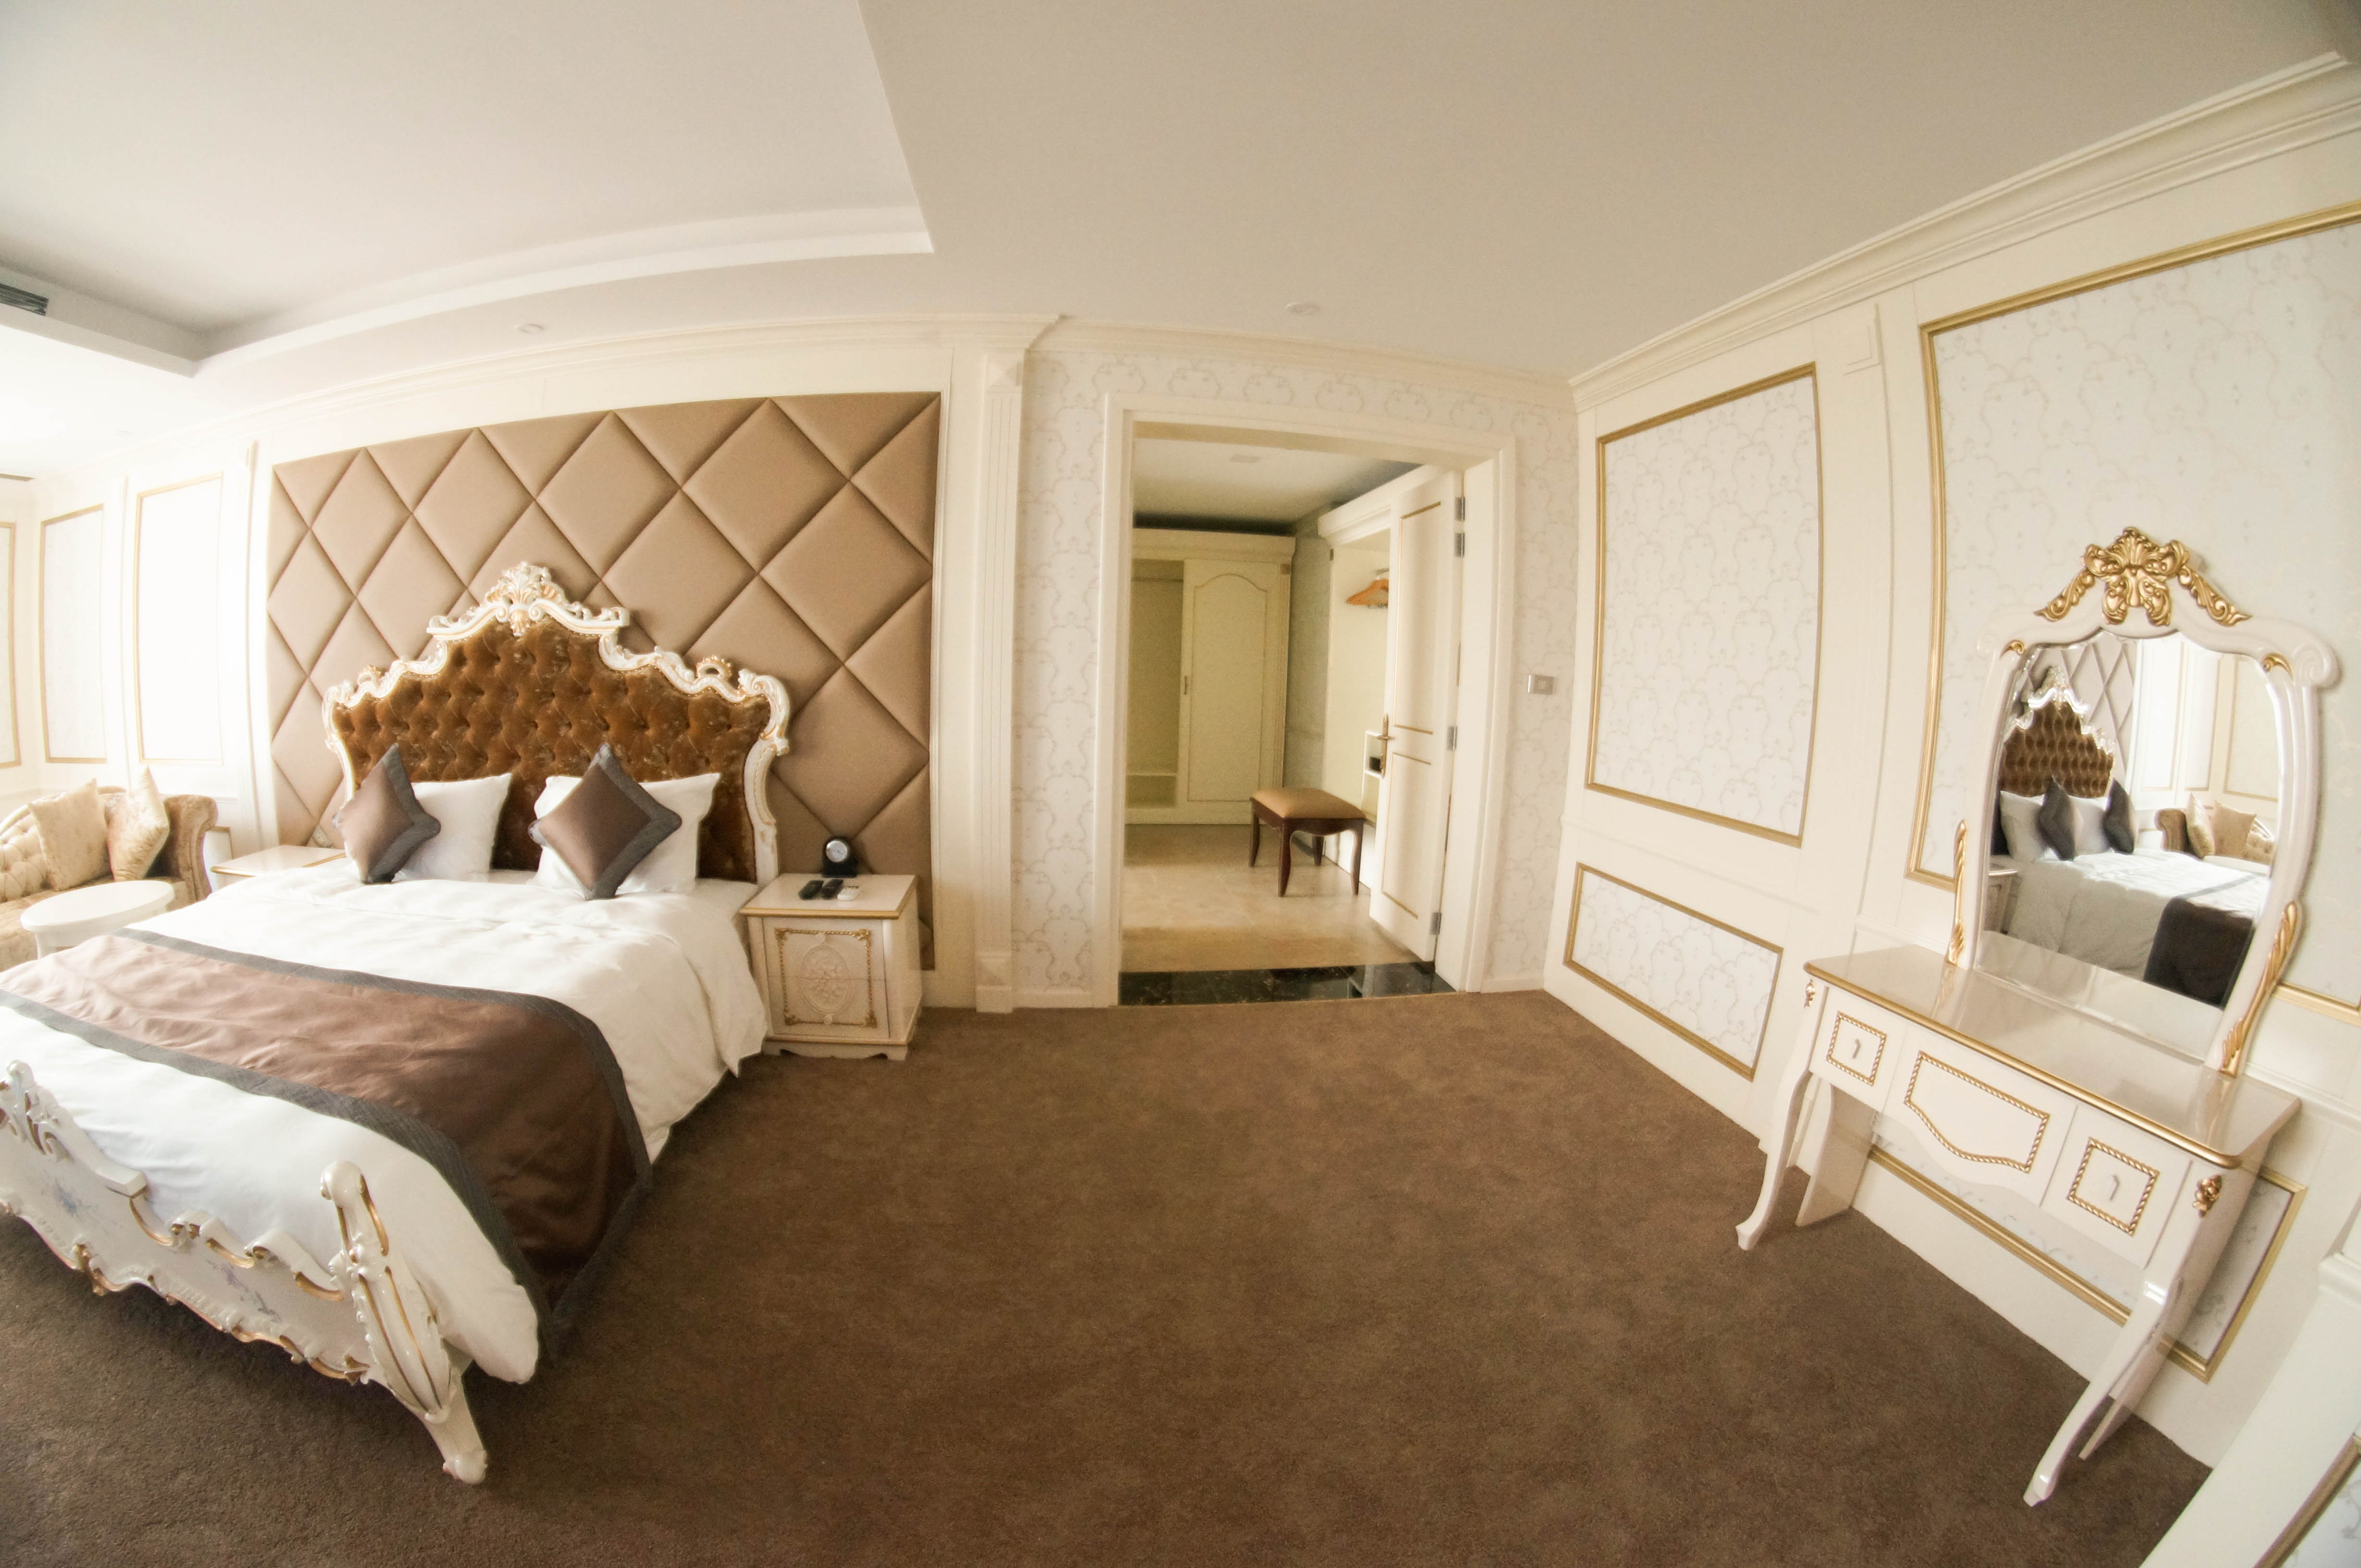

MUONG THANH HOTEL
Add: Dong Ve Ward, Thanh Hoa City, Thanh Hoa Province, Vietnam

FINANCIAL CONDITION:

- Participants fee: 100USD/person
(Please pay the fee to AKF directly at the registration.)
- Hotel:

HEADQUARTER/OFFICIAL HOTEL
Name | Rank | PACKAGE (per persons) From 20th - 22nd  May 2015 |  | Remark
 |  | Single  Room | Double/Triple  Room
MUONG THANH HOTEL | **** | 175 USD | 250 USD | This price includes:  *Room rate includes 3 meals per day per head. (breakfast, Lunch & Dinner)

- Transportation:

No. | Venue | Transportation | Price | Remark
1 | Noi Bai Int’l airport (Hanoi) to HQ Hotel (Thanh Hoa) and return. | 7 seats car | 300USD | * Please note that, Organizing committee receive all participants at the Noi Bai Int’l airport only.
2 |  | 16 seats | 400USD
3 |  | 37 seats | 500USD
4 |  | 45seats | 600USD

For more information about fees and transportations time, please contact VKF by email at: sonhakarate@yaoo.com; lhhanh2502@yahoo.com

Please note:
- Insurance All participants are to arrange for their own insurance.
- The hotel must be reserved through the VKF before 20th April 2016.
- Please note that, all participating countries must directly pay by cash to the organizing Committee upon arrival.

VISA INFORMATION

In order to ensure entry visas for participants concerned, VKF is responsible for preparing the official invitation for their visa application. Please submit the required for the invitation letter to VKF as early as possible, but in any case no later than the deadline required as below.

Required Documents:
1. PASSPORT COPIES: Scanned copy of the personal information page of the passport must be sent to VKF together with the application form no later than March 20th, 2016.
2. Passport must be with at least 6 months of remaining validity and enough blank visa pages.
Remark: VKF will take no responsibility for possible reject of visa as a result of following actions, such as failing to meet the above requirements, late registration, other hotel reservation rather than HQ hotel, or payment delay and etc.

Thanh Hoa Provice

The province of Thanh Hoa is located in the North Central Vietnam. Its farthest north point of land is 110 km south of Hanoi.
Being one of the largest provinces in Vietnam with an area of 11,106 km2 and the population of over 3,4 million working and living in 27 districts, towns and city, Thanh Hoa has an original geographical location together with the rough river system, mighty mountains and the immense sea.

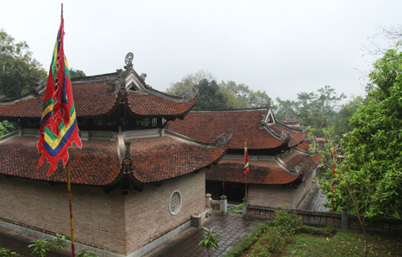
Ba Trieu Temple is the mark not only the history but also kept many rare artifacts. This architecture is also unique art in Thanh Hoa

Thanh Hoa, a land of confidence and activeness are making great contribution to the changing process of the country and to the modernization and industrialization activities with growing numbers of factories, industrial zones, processing areas.
Those are the polyhedron image of the holy land with its talented people which is on the rise to the global integration with its proud past and the vehement vitality for the present and the future.

INFORMATION
COUNTRY : |  | PHONE NUMBER :
FEDERATION : |  | EMAIL :
NAME : |  | FAX :

ARRIVALS | DEPARTURE
DATE | DATE
TIME | TIME
AIRPORT | AIRPORT
AIRLINES NUMBER | AIRLINES NUMBER

REGISTRATION

No. | NAME | GENDER | CATEGORIE | DEGREE BELT | WEIGHT
1
2
3
4
5
6
7
8
9
10
DEADLINE REGISTRATION : april 20, 2016.
A. Please submit a separate folder including all e-format photos of your delegation together with entry form.
B. Each photo should be saved in the person’s name plus his position. (For example: Full Name, Position).
CONTACT : VIETNAM KARATE FEDERATION (VKF)
E-mail: sonhakarate@yaoo.com; lhhanh2502@yahoo.com.

