|  |  |
| --- | --- |
|  |  |

**VIETNAM OPEN**

**KARATE-DO CHAMPIONSHIP 2016**

**23rd - 27th May 2016**

|  |
| --- |
|  |

**THANH HOA, VIETNAM**

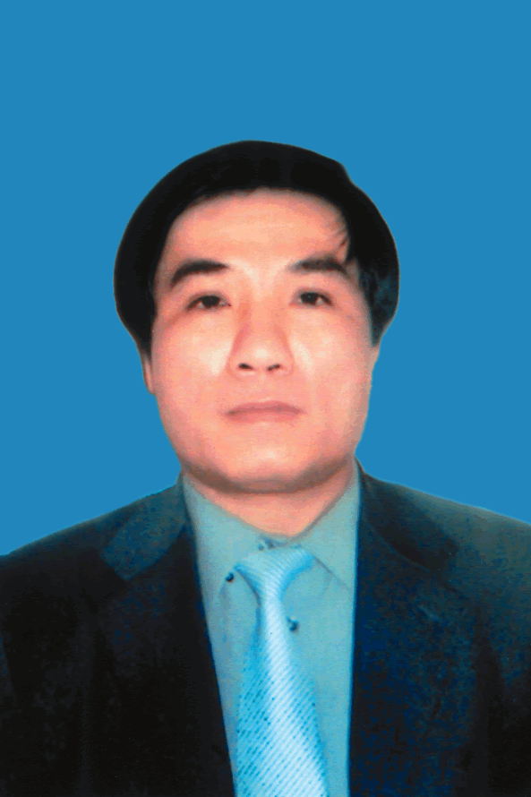

*Message of Mr. Pham Dang Quyen*

*Vice Chairman of People's Committee of Thanh Hoa Province*

*Chairman of Organizing Committee of Vietnam Open Karate-do Championship, 2016, Thanh Hoa, Viet Nam*

Dear Distinguished guests, officials, coaches and competitors.

On behalf of the People's Committee of Thanh Hoa Province, I would like to send my warmest greetings to distinguished guests, head of delegations, referees, coaches and players participating in the Vietnam Open Karate-do Championship and the AKF Training Camp from 20th - 27th May 2016 in Thanh Hoa province of Viet Nam.

It is our honor to host Vietnam Open Karate-do Championship and the AKF Training Camp in Thanh Hoa, Viet Nam and welcome you all to these events. We are trying our best efforts to ensure distinguished guests, officials, coaches and competitors enjoy your stay in Thanh Hoa, a city located in the North Central of Vietnam and have many attractions.

I also would like to thank the Asian Karatedo Federation who has supported us in organizing this meaningfull event.

Best wishes and good lucks to all participants.

Great success to the Vietnam Open Karate-do Championship and the AKF Training Camp 2016.

Thank you.

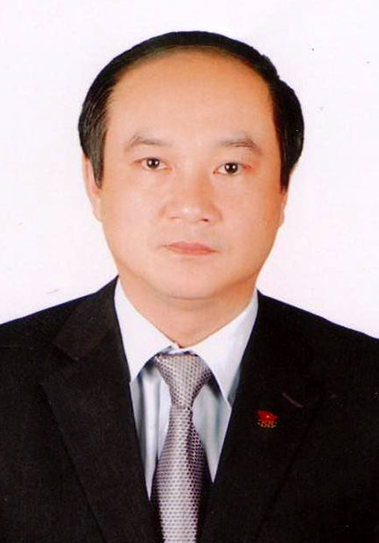

*Speech by Mr. Vuong Bich Thang,*

*Chairman of Viet Nam Sports Administration,*

*Deputy President of Viet Nam Olympic Committee,*

Ladies and gentlemen,

I would like to take this opportunity to extend my greetings and best wishes to all participants of the Vietnam Open Karate-do Championship and the AKF Training Camp from 20th - 27th May 2016 in Thanh Hoa province of Viet Nam.

I highly appreciate the efforts and dedication of the Department of Culture, Sports and Tourism of Thanh Hoa Provice and Viet Nam Karatedo Federation in making such good preparation for the events.

I believe that competitors will perform in a sportsmanlike spirit with sensational display and achieve great results. I sincerely hope that all participants will enjoy their stay in Thanh Hoa with nice memories.

On behalf of the people working in sport field, I would like to express my sincere gratitude to People’s Committee of Thanh Hoa Province, Asian Karatedo Federation for the great support to the events.

May I wish the event a great success.

May I wish all participants good health and happiness.

**Vietnam Open Karate-do Championship 2016**

***Event Information***

**I. Date**

May 23rd - 27th, 2016.

## II. Venue

**1. Competition Venue:**

- Sport Training and Competition Center of Thanh Hoa Province.

- Add: No. 89 Le Hoang Str., Dien Bien Ward, Thanh Hoa City, Thanh Hoa Province.

**2. Accommodation:**

- HQ Hotel: Muong Thanh Hotel (4 stars); Add: Dong Ve Ward, Thanh Hoa City, Thanh Hoa Province.

- Lam Kinh Hotel (4 stars); Add: Le Loi Str., Dong Huong, Thanh Hoa City.

**III. Organizers**

This Championship is organized by the Vietnam Karate Federation (VKF) in conjunction with the Vietnam Sports Administration (VSA) and the Asian Karatedo Federation (AKF).

## IV. Supervision

The Championship will be supervised by the Organizing Committee (OC) of Vietnam Open Karate-do Championship 2016, created by the VKF.

## V. Categories

A Senior

* Age: +18 (Born before December 31, 1998).
* Individual Kumite:

Female: -50kg, -55kg, -61kg, -68kg, +68kg;

Male: -55kg, -60kg, -67kg, -75kg, -84kg, +84kg.

* Individual Kata: Female & Male.
* Team Kata: Female & Male.
* Team Kumite: Female (3+1).
* Team Kumite: Male (5+2).

B Junior

* Age: Age 16/17 (Born between January 1, 1999 and December 31, 2000).
* Individual Kumite:

Female: -48kg, -53kg, -59kg, +59kg;

Male: -55kg, -61kg, -68kg, -76kg, +76kg.

* Individual Kata: Female & Male
* Team Kata: Female & Male

C Cadet

* Age: 14/15 (Born between January 1, 2001 and December 31, 2002)
* Individual Kumite:

Female: -47kg, -54kg, +54kg;

Male: -52kg, -57kg, -63kg, -70kg, +70kg.

● Individual Kata: Female & Male.

D Boys/Girls

* Age: 12/13 (Born between January 1, 2003 and December 31, 2004).
* Individual Kumite:

Female: -43kg, +43kg;

Male: -48kg, +48kg.

* Individual Kata: Female & Male.

**VI. Competitors**

* + Each participating country/club may enter up to 2 male and 2 female competitors for each weight division of the individual Kumite competition and the individual kata competition
  + Each participating team may enter up to 2 male and 2 female teams for each team Kata event.
  + Each event/category must have at least 4 participants. Failing which, the event/category will either be scrapped or combined with another event/category.
  + Every competitor attending this event should submit both Entry forms A and B by the given deadlines.

**VII. Safety Equipment; the following protective is compulsory**

WKF approved Gi, Obi, Gloves, Gum shield, Body protection plus Chest protector (for female),

Shin pad, Foot protection & Face mask for Cadet. All contestants must provide their own WKF-approved protective items. The OC is not in charge of providing these items to all athletes. Groin Guards are not mandatory but if worn must be of approved WKF type.

**VIII. Rules**

WKF Rules; The tournament shall be conducted in accordance with WKF Rules of competition Version 9.0 effective from 1.1.2015.

●Duration of Bout for Senior; Kumite match will be 3 minutes for male & 2 minutes for female. However, in the final and repechage final it should be 4 minutes for male & 3 minutes for female individual Kumite.

●Duration of Bout for Cadet & Junior; 2 minutes in all cases for Kumite.

●Duration of Bout for Under 13 years; 1.30 minutes in all cases for Kumite.

**IX. Referees**

The VKF would like to request that every participating country recommend at least 2 AKF or WKF judges/referees for this event. All qualified personnel will immediately be installed as the event’s referees.

* + Technical Delegate to the championship: Mr. Chee Jin (Patrick) Lim (MAS)

**X. Expenses**

1. **Entry (Participation) Fees:**

* Individual Categories
  + Participation Fee: Age of 12 - 17 US$40.00 per person for each category
  + Participation Fee: Age of 18 or above US$40.00 per person for each category
* Team Categories
  + Participation Fee: US$70 per team

1. **Accomodation:**

- US$50.00 per person/day

*Including: Room rate and 3 meals per day per head. (breakfast, Lunch & Dinner)

1. **Transportation:**

|  |  |  |  |  |
| --- | --- | --- | --- | --- |
| **No.** | **Venue** | **Vehicles** | **Price** | **Remark** |
| 1 | Noi Bai Int’l airport (Hanoi) to HQ Hotel (Thanh Hoa) and return. | 7 seats | **300USD** | **Please note that, organizing committee receive all participants at the Noi Bai Int’l airport only.** |
| 2 | 16 seats | **400USD** |
| 3 | 37 seats | **500USD** |
| 4 | 45 seats | **600USD** |

For more information about fees and transportations time, please contact VKF by email at: [sonhakarate@yaoo.com](mailto:sonhakarate@yaoo.com); [lhhanh2502@yahoo.com](mailto:lhhanh2502@yahoo.com)

***Please note:***

- Insurance: All participants are to arrange for their own insurance.

- The hotel must be reserved through the VKF before 20th April 2016.

**XI. Registration Deadline**

The OC would greatly appreciate if the participants could submit the forms by the dates given below:

Application Forms & Deadline**:**

|  |  |  |
| --- | --- | --- |
|  | Forms | Deadline |
| 1 | Name List of Participants (without Contestants) (Entry Form B) | April 20, 2016 |
| 2 | Entry by Name (with 2 color photos 3 cm x 4 cm) (Entry Form B) |
| 3 | Terms of Responsibility |
| 4 | Hotel Reservation |
| 5 | Flight Information | May 1, 2016 |

**XII. VISA information**

In order to ensure entry visas for participants concerned, VKF is responsible for preparing the official invitation for their visa application. Please submit the required documents below to VKF as early as possible, but in any case no later than the deadline required as below.

Required Documents:

1. PASSPORT COPIES: Scanned copy of the personal information page of the passport must be sent to VKF together with the application form no later than March 20th, 2016.

2. Passport must be with at least 6 months of remaining validity and enough blank visa pages.

**Remark:** VKF will take no responsibility for possible reject of visa as a result of following actions, such as failing to meet the above requirements, late registration, other hotel reservation rather than HQ hotel, or payment delay and etc.

**XIII. Payment Method**

- Please note that, all participating countries must directly pay by cash to the organizing Committee upon arrival.

*In case of any changes in competition category or in any arrival schedule changes, the fee of 30 USD will be applied.

*In case of late registration payment, 10% charge fee will be applied.

**XIV. Insurance**

All participants are to arrange for their own insurance.

**XV. Fixture**

A Team Manager Meeting and Draw will be conducted. The date, time and venue would be confirmed later.

**XVI. Organizing Committee (OC)**

The OC will host a Farewell Party for all participants on May 27, 2016.

**XVII. Contact**

If you have any questions or concerns, please feel free to contact us

**Address:** Vietnam Karate Federation

Email: [sonhakarate@yaoo.com](mailto:sonhakarate@yaoo.com); [lhhanh2502@yahoo.com](mailto:lhhanh2502@yahoo.com)

**XVIII. SCHEDULE**

The schedule is subject to change upon the number of the participants.

|  |  |  |  |
| --- | --- | --- | --- |
| Date/Time | | Description | Place |
| 23/05/2016 | 10.00-23.00  13.00-17.00 | * Arrival of Officials, Athletes and Delegations * Nation's team & Referees Registration | HQ Hotel  HQ Hotel |
|  |  |  |  |
| 24/05/2016 | 09.00-12.00  10.00-18.00 11.00-12.00  12.00-13.00  13.00-14.00  14.30-16.30 | * Nation's team & Referees Registration * Nation's team Training * RC Meeting * Lunch Break * Officiating Referees briefing * Team Manager & Coach Meeting & Draw | HQ Hotel  Training  Training  HQ Hotel  HQ Hotel  HQ Hotel |
|  | |  |  |
| 25-05-2016 | 08.00-09.00  09.00-09.30  09.30-17.30 | * Weigh-in   Open Ceremony   * Championship  1. Boys/Girls Individual Kata: 12-13 years 2. Cadet Individual Kata: Female & Male 3. Junior Individual Kata: Female & Male 4. Junior Team Kata: Female & Male 5. Senior Individual Kata : Female & Male 6. Senior Team Kata : Female & Male 7. Boys/Girls Individual Kumite : 12-13 yr   - Awarding Ceremony | Competition  Venue  Competition  Venue |
|  | |  |  |
| 26-05-2016 | 08.30-09.30  09.30-17.30 | * Weigh-in * Championships  1. Boys/Girls Individual Kumite : 12-13 yr   2. Cadet Individual Kumite Female  3. Cadet Individual Kumite Male  4. Junior Individual Kumite Female  5. Junior Individual Kumite Male  - Awarding Ceremony | Competition Venue  Competition  Venue |
|  | | | |
| 27-05-2016 | 09.00-16.30          16.30-17.30    19.00-21.00 | * Championships   1. Senior Individual Kumite   Female: -50,-55,-61,-68,+68 Kg. Male: -55,-60,-67,-75,-84,+84 Kg   * 1. Team Kumite * Awarding Ceremony * Closing Ceremony   - Farewell party (All participants) | Competition  Venue    Competition  Venue        Outside  Restaurant |
| 28-05-2016 | 06.00-20.00 | - Departure |  |

1. **Weigh-in**

Competitors in each category shall weigh-in on the morning of their respective competition days at competition venue. The weigh-in shall begin at 08.30 hrs and close at 09.30 Hrs. of each day.

Competitors who fail to make the weigh-in shall be disqualified. Latecomers shall also be disqualified.

* 1. ***Weigh-in Attire*** 
     + Male competitors shall be weighed wearing only underwear. Female competitors shall be weighed in T-shirts and karate slacks.
  2. ***Weigh-in Officials*** 
     + The Technical delegate shall appoint at least (Two) referees to supervise the weigh-in each morning,

At the end of each weigh-in day, the two referees shall report to the technical delegate the result of the weigh-in and their comments, if any.

1. **Drawing of Lots**

The drawing of lots will be conducted by technical delegate or his representation appointed by the Organizing - Committee; the drawing of lots will be conducted in alphabetical order according to the official names of the participating teams as submitted to VKFOC. The participating teams are welcome to attend the draw.

1. **National Flag & Anthem**

Please submit two national flags (1m x 1.5m) and 1 national anthem CD at the registration.

1. **Photos**
   * + Please submit a separate folder including all e-format photos of your delegation together with entry form (color photos 3x4 cm in white background).

- Each photo should be saved in the person’s name plus his position. (For example: Full Name, Position).

E. **Language**

English is an official language used for this competition. We would recommend each team to have at least one person who can communicate in English.

**HOTEL RESERVATION FORM**

By__________________

PLEASE E-MAIL TO: [sonhakarate@yaoo.com](mailto:sonhakarate@yaoo.com); [lhhanh2502@yahoo.com](mailto:lhhanh2502@yahoo.com) on or before **20th April 2016**

|  |  |  |  |
| --- | --- | --- | --- |
| COUNTRY: |  | FEDERATION: |  |
| Name of Delegation Representative: | |  | |
| Address: |  | | |
|  | | |
|  | | |
| Tel: |  | Fax: |  |
| FLIGHT INFORMATION: | | | |
| ARRIVAL: | | DEPARTURE: | |
| DATE: |  | DATE: |  |
| TIME: |  | TIME: |  |
| FLIGHT NO: |  | FLIGHT NO: |  |
| NO. OF PERSONS: |  | NO. OF PERSONS: |  |
|  | | | |
| Transport (Airport to Hotel) Required Not Required | | | |  |  |

**NAME LIST**

PLEASE E-MAIL TO: [sonhakarate@yaoo.com](mailto:sonhakarate@yaoo.com); [lhhanh2502@yahoo.com](mailto:lhhanh2502@yahoo.com) on or before **20th April 2016**

Country: ______________ Federation: ________________________

Person-in-charge: _________________

Tel: _____________ Fax: ____________ E-mail: ______________________

Check-in Date: ___________________ Check-out Date: _________________

|  |  |  |  |  |  |
| --- | --- | --- | --- | --- | --- |
| No | Last Name | First Name | Position * | Single=S Twin = T | Please indicate (using No. from the first column) who shares with whom |
|  |  |  |  |  |  |
|  |  |  |  |  |  |
|  |  |  |  |  |  |
|  |  |  |  |  |  |
|  |  |  |  |  |  |
|  |  |  |  |  |  |
|  |  |  |  |  |  |
|  |  |  |  |  |  |
|  |  |  |  |  |  |
|  |  |  |  |  |  |
|  |  |  |  |  |  |
|  |  |  |  |  |  |
|  |  |  |  |  |  |

* Position: C=Competitor, Co=Coaches, De=Delegation Head, P=Presidents & Leaders of National Federation, R=Referees/Judges, D=Doctors, V=VIPs, A=Administration, P=Press, O=Others

**APPENDIX (B)**

|  |
| --- |
| Sender: |
| Dojo/Country: |
| Address: |
|  |
|  |
| Tel: |
| E-mail: |
| Signature |

|  |  |  |  |  |  |  |  |  |  |
| --- | --- | --- | --- | --- | --- | --- | --- | --- | --- |
| **Individual Kata** | | **Male** | | | | **Female** | | | |
| **No.** | **Name** | 12/13 | Cadet | Junior | Senior | 12/13 | Cadet | Junior | Senior |
|  |  |  |  |  |  |  |  |  |  |
|  |  |  |  |  |  |  |  |  |  |
|  |  |  |  |  |  |  |  |  |  |
|  |  |  |  |  |  |  |  |  |  |
|  |  |  |  |  |  |  |  |  |  |
|  |  |  |  |  |  |  |  |  |  |
|  |  |  |  |  |  |  |  |  |  |

|  |  |  |  |  |  |
| --- | --- | --- | --- | --- | --- |
| **Team Kata** | | **Male** | | **Female** | |
| **No.** | **Name** | Junior | Senior | Junior | Senior |
|  |  |  |  |  |  |
|  |  |  |  |  |  |
|  |  |  |  |  |  |
|  |  |  |  |  |  |
|  |  |  |  |  |  |
|  |  |  |  |  |  |
|  |  |  |  |  |  |

|  |  |  |  |  |  |
| --- | --- | --- | --- | --- | --- |
| **Individual Kumite 12/13** | | **Male** | | **Female** | |
| **No.** | **Name** | -48kg | +48kg | -43kg | +43kg |
|  |  |  |  |  |  |
|  |  |  |  |  |  |
|  |  |  |  |  |  |
|  |  |  |  |  |  |
|  |  |  |  |  |  |
|  |  |  |  |  |  |
|  |  |  |  |  |  |
|  |  |  |  |  |  |
|  |  |  |  |  |  |

|  |  |  |  |  |  |  |  |  |  |
| --- | --- | --- | --- | --- | --- | --- | --- | --- | --- |
| **Individual Kumite Cadet** | | **Male** | | | | | **Female** | | |
| **No.** | **Name** | -52kg | -57kg | -63kg | -70kg | +70kg | -47kg | -54kg | +54kg |
|  |  |  |  |  |  |  |  |  |  |
|  |  |  |  |  |  |  |  |  |  |
|  |  |  |  |  |  |  |  |  |  |
|  |  |  |  |  |  |  |  |  |  |
|  |  |  |  |  |  |  |  |  |  |
|  |  |  |  |  |  |  |  |  |  |
|  |  |  |  |  |  |  |  |  |  |
|  |  |  |  |  |  |  |  |  |  |
|  |  |  |  |  |  |  |  |  |  |

|  |  |  |  |  |  |  |  |  |  |  |
| --- | --- | --- | --- | --- | --- | --- | --- | --- | --- | --- |
| **Individual Kumite Junior** | | **Male** | | | | | **Female** | | | |
| **No.** | **Name** | -55kg | -61kg | -68kg | -76kg | +76kg | -48kg | -53kg | -59kg | +59kg |
|  |  |  |  |  |  |  |  |  |  |  |
|  |  |  |  |  |  |  |  |  |  |  |
|  |  |  |  |  |  |  |  |  |  |  |
|  |  |  |  |  |  |  |  |  |  |  |
|  |  |  |  |  |  |  |  |  |  |  |
|  |  |  |  |  |  |  |  |  |  |  |
|  |  |  |  |  |  |  |  |  |  |  |

|  |  |  |  |  |  |  |  |  |  |  |  |  |
| --- | --- | --- | --- | --- | --- | --- | --- | --- | --- | --- | --- | --- |
| **Individual Kumite +18** | | **Male** | | | | | | **Female** | | | | |
| **No.** | **Name** | -55kg | -60kg | -67kg | -75kg | -84kg | +84kg | -50kg | -55kg | -61kg | -68kg | +68kg |
|  |  |  |  |  |  |  |  |  |  |  |  |  |
|  |  |  |  |  |  |  |  |  |  |  |  |  |
|  |  |  |  |  |  |  |  |  |  |  |  |  |
|  |  |  |  |  |  |  |  |  |  |  |  |  |
|  |  |  |  |  |  |  |  |  |  |  |  |  |
|  |  |  |  |  |  |  |  |  |  |  |  |  |
|  |  |  |  |  |  |  |  |  |  |  |  |  |

|  |  |  |  |  |
| --- | --- | --- | --- | --- |
| **Team Kumite +18** | | | **Male** | **Female** |
| **No.** | **Surname** | **First Name** |  |  |
|  |  |  |  |  |
|  |  |  |  |  |
|  |  |  |  |  |
|  |  |  |  |  |
|  |  |  |  |  |
|  |  |  |  |  |
|  |  |  |  |  |

**COMPETITION HALL**

|  |
| --- |
|  |
|  |
|  |

**MUONG THANH HOTEL**

|  |
| --- |
|  |
|  |
|  |

**LAM KINH HOTEL**

|  |
| --- |
|  |
|  |
|  |

**About Thanh Hoa**

The province of Thanh Hoa is located in the North Central Vietnam. Its farthest north point of land is 110 km south of Hanoi. It borders Laos to the west with 192 km of land borders running through mountainous areas. Its northern neighboring provinces are Ninh Binh, Hoa Binh and Son La with 175 km of land borders, and 160 km shared with Nghe An province to the south. Thanh Hoa lies on the shore of South China Sea which enjoys 102 km of coastline. Throughout the country’s history, Thanh Hoa remained its border stability. The province is home to 7 ethnic groups including: Kinh, Muong, Thai, Dao, Mong, Tho and Kho Mu which have different ways of lifestyle creating a multi-colored picture of Thanh Hoa’s culture. Thanh Hoa has an ideal geographical location which enjoys the characteristics of three economic zones: mountainous area, midland and seaside delta. The province is rich in natural resources including soil fertility, forests and minerals and it is referred to as a small version of Vietnam.

|  |
| --- |
|  |

 Being one of the largest provinces in Vietnam with an area of 11,106 km2 and the population of over 3,4 million working and living in 27 districts, towns and city, Thanh Hoa has an original geographical location together with the rough river system, mighty mountains and the immense sea. At the dawn of human being, this place was the home of the ancient local people. According to the excavation results, during the ancient Stone Age which dates back as far as a few thousand years ago, three ancient civilizations including: Vi Son, Hoa Binh, Bac Son flourished in the archaeological sites of Do Mountain and Con Moong Cave (Thach Thanh) and later the finding of Dong Son civilization once again proved the long standing existence of this historic land.

|  |
| --- |
|  |

Located in the North Central Vietnam, Thanh Hoa is a place of holy land and talented people which has plentiful cultural traditions. Throughout many years of struggling against the nature to survive, Thanh Hoa people managed to create their own distinctive cultural features which are reflected in the diversified cultural heritages. These include the handicraft villages of Kinh. Muong, Dao, Thai, Tho with handicrafts such as the stone carving of An Hoach village (Dong Son), the forging of Tat Tac (Hau Loc), the bronze casting of Tra Dong, the earthenware making of Duc Tho Van village, the paper making of Dao ethnic group (Ngoc Lac), the weaving of Tho (Nhu Thanh), the linen making of Mong (Quan Son), the brocade weaving of Thai and Muong people (Ba Thuoc, Ngoc Lac) … There are legends, anecdotes, cultural folks, art performances and a wide range of theatrical performances which appeared a long time ago and have constantly been refined to the present days. These include Xuan Pha folk performance (Tho Xuan), Chieng and Chut (Yen Dinh), Dong Anh folk songs, Xuong Rang, Bo Meng of Muong group, Ca Sa, Kin Chieng, Booc May of Thai people, Chuong and Rua dancing of Dao people…all of which are regularly seen in hundreds of traditional festivals which are held annually across the province. The typical festivals include Ba Trieu, Le Hoan, Lam Kinh, Quang Trung… Apart from those cultural features, Thanh Hoa is fortunately granted by the nature a wide range of beautiful landscapes and a system of mountain caves such as Bich Dao, Long Quang, Kim Son, Ho Cong… The tropical ecosystem has created some ideal ecotourism sites like Natural Reserve of Ben En, Pu Hu, Pu Luong, Tam Quy... all of which contribute to enrich the spiritual lives of Thanh Hoa people.



Thanh Hoa also has the tradition of heroic and unyielding struggles, a place in which many feudal dynasties originally rose up. The land was involved in the existing, perishing as well as flourishing process of the country. The contribution of Thanh Hoa people have helped to create many glorious pages in our history. Such well known individuals were Trieu Thi Trinh, Le Hoan, Le Loi, Duong Dinh Nghe, Ngo Quyen…whose merits helped to establish many dynasties in the nation’s history such as Le dynasty, Ho dynasty, Nguyen Dynasty. In addition, this holy land is the home of many famous Lords. Trinh Lord had his 249 years of ruling the country, Nguyen Lords, especially Nguyen Hoang is credited with having reclaimed the land to the South, stabilized the borders of the country between the 17th and 18th century creating favorable conditions for the next generations of Nguyen Lords to unite the country.

Thanh Hoa is not only the homeland of Three Kings and two Lords, but also the land of traditional fondness for learning. In the competition examinations of our country’s history, Thanh Hoa had 1627 laureates of whom 240 had the doctor title with popular names in fields like literature, history, military, foreign relation for, instance Khuong Cong Phu, Le van Huu, Dao Duy Tu…

During the two resistance wars against French colonist and American imperialist, Thanh Hoa people overcame many difficulties to be a great supporting rear for the front whose contributions helped to get the victory of Dien Bien Phu as well as the victorious Ham Rong and the final victory of spring 1975.

The more you get to know about the land and people of Thanh Hoa, the more amazed you will find at another version of Vietnam with its beauty and full of vitality. This is the converging place of the spirits of mountains and rivers where the tradition spring has been continuously running.

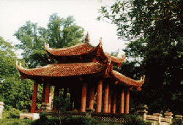

The heroic Thanh Hoa in the history of resistance wars with the image of elephant riding of the heroine Trieu Thi Trinh and the resounding spirits of Lam Son insergant army, Ba Dinh, Ma Cao, Hung Linh, Ham Rong-Song Ma.

The ancientness of Thanh Hoa with architectural features related to the existing, perishing as well as flourishing process of the Vietnam’s imperial dynasties. A land which boasts its charming beauty, strength and full of vitality with Ma river shanty, Dong Anh traditional dances, Xuan Pha dance and Cheo Chai.

Thanh Hoa, a land of confidence and activeness are making great contribution to the changing process of the country and to the modernization and industrialization activities with growing numbers of factories, industrial zones, processing areas.

Those are the polyhedron image of the holy land with its talented people which is on the rise to the global integration with its proud past and the vehement vitality for the present and the future.

